 **27 Mar 2015** **The Weekly Bulletin of Rotary Club of Kathmandu Mid-Town** **bc-37/3.015**

|  |
| --- |
|  |

District: 3292 Web:www.rotarymidtown.org.np Club Id: 26776

**MARCH IS THE LITERACY MONTH**

**“Literacy is a human right, a tool of personal empowerment and**

**a means for social and human development.”**

Club’s Weekly Meeting # 1271 on Friday, 20 March:

Extracts of the Minutes :

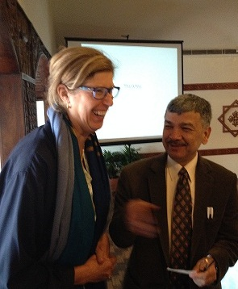

“1. 2nd VP HE Lisa called meeting #1271 to order.

“3. Members and guests were welcomed; Mr Pino Servino, Mr Tenzin Sherpa

(son of Treasurer Jo), visiting Rotarian David Sowerwine and 2 friends

from Village Tech Solutions..

“7. Guest speaker Dr Rup Khadka was introduced by his long-time friend CP

Dr Roop Jyoti. Dr Khadka spoke on 'The Nepal Tax System' and about the

different taxes that are levied in Nepal: VAT, excise tax, customs tax,

individual income tax, corporate income tax, withholding tax and other

minor taxes. A very lively Q&A followed with members requesting various

clarifications. Club Affairs Chair Rtn Bhairaja gave the vote of thanks.

”8. Information sharing:

> Reminder: Mid-Town Pot Luck Dinner on March 28, 2015 at the home

of Rtn Sheri (adjacent to the British School in Kupondole). Each Mid-Towner

will be given 10 raffle tickets to sell. 500 Nrs per ticket. It would be ideal if

each member sold at least 5 tickets. Many wonderful prizes to be won

including Grand Prizes: 2 nights for 2 at Tiger Mountain Pokhara Lodge;

2 nights for 2 at Dwarika's Himalayan Shangri-La Village Resort and airline

ticket 'surprise' courtesy of Osho World Travel Nepal Pvt. Ltd. Rtn Bhairaja

announced that there would be a prize for the Mid-Towner who sold the greatest number of tickets.

> Friday March 27th will be a 'Club Affairs' meeting.

> Reminder: Rotary Youth Leadership Awards (RYLA) 30 March-2 April --develops leadership 18-23 year olds.

> Reminder: Preparations for the RI Convention in Rio – early registration ends March 31 – sign up now – last week's Minutes contain visa application information.

> PP Komal conveyed a message from PP Iswar (RC Patan) for a program by Dr. Bibek Pradhan at the joint meeting is

finalized on 24th March (Tuesday) at RC Kantipur @ Hotel Sankar @ 5:30 pm. You are requested to confirm to

President Uttam Bhattarai 9851020613 regarding your club's participation so that Rtn. Uttam is enable to arrange for

high tea which costs Rs. 700/- (Seven Hundred).

> PP Ajay announced that there were still 2 seats available for the visit to Sindupulchowk immediately following the

meeting. Mid-Towners were headed to see the work taking place at the school and the construction of the training

centre for the First Steps Himalaya Project.

> PP Yogendra reminded everyone that RC Mid-Town needed to hand in their nomination for DGN since it will now

have to go by balloting. The Club was unanimous that its vote should go to Rtn Sanjay Giri. VP Lisa will sign the form

and PP Yogendra will do the needful to see that the paperwork is submitted on time.

> There was an inquiry on the health of VP HE Peter Bodde. VP Lisa reported that he is well, that he should be

discharged soon and would be on his way to his son's wedding celebration in the US.

> Rtn Govinda invited all to his son's 7th birthday celebration.

“9. Statistics of the meeting: Members present: 25”

# Weekly Meetings and Programs :

|  |  |  |
| --- | --- | --- |
| Date | Program/ Speaker | Topic of Presentation |
| 27 March | Club Affairs |  |
|  |  |  |

Weekly Meeting on Friday, 27 March:

Club Affairs meeting;

**Mid-Towners’ Potluck**

**Tomorrow (Saturday, 28 March 2015)**

**Venue: At Rtn Sheri’s House (adjacent to the British School in Kupondole)**

The organizers expect each Mid-Towner to sell at least 5 raffle tickets of Rs 500 each.

Many wonderful prizes to be won including Grand Prizes: 2 nights for 2 at Tiger Mountain Pokhara Lodge;

2 nights for 2 at Dwarika's Himalayan Shangri-La Village Resort and

airline ticket 'surprise' courtesy of Osho World Travel Nepal Pvt. Ltd

**RYLA – 2015, “Youth for Change”**

The Rotary Youth Leadership Awards program seeks to provide young adults, ages 14-30, with an opportunity to develop their skills and character while exposing them to Rotary’s values of service, high atthical standards and peace. A three day RYLA 2015 is being organized on 30 March through 2 April in Kathmandu.

The RYLA Program details:

Program dates: 30 March – 2 April

Venue: DAV School, Jawalakhel

Registration: Rs 2,500 per participant

Participants of age group: 18 – 23 years.

RYLA 2015 management committee: Rotary Clubs of Pashupati, Kasthmandap, Jawalakhel, Mahaboudha,

Baneshwor, Yala, Metro, Kathmandu-North, Patan-South, Kathmandu-West and Rotary e-Club.

**Visiting Early Childhood Development Project (MG# 77952)**

**in Sindhupalchowk**

A team of Rotarians from our Club visited Sindhupalchowk on Friday 20 March to see our completed works under Early Childhood Development project, MG# 77952 . Mr. Durga Aran, Founder/Chair of First Steps Himalaya welcomed the team led by Rtn Ajaya Sthapit. Ms. Fionna Heiton, co-founder of First Steps Himalaya, along with Durga briefed on project activities, improvement in children’s interest in school attendance, as well as new work taking place for the construction of the training centre on their own with help of NZ organisation.

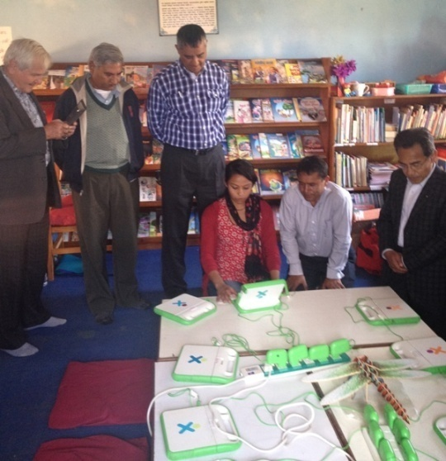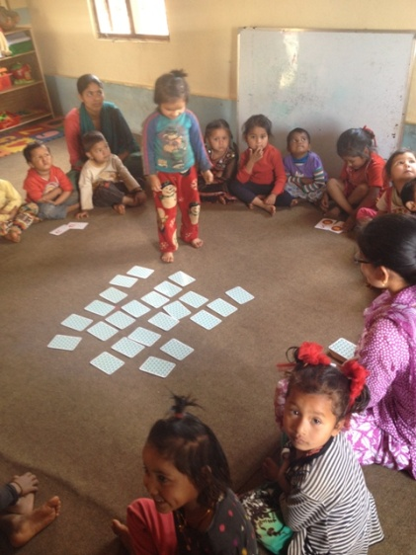 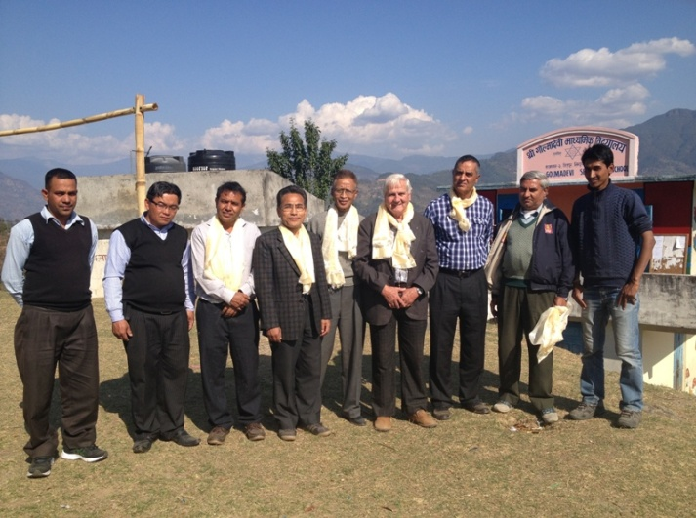

**60 Tons of Cosmic Dust Fall to Earth Every Day !**

The earth is a dirty place, and we aren't getting much help from space. Every day, dust from meteorites, comets, and other 4.6 billion-year-old pieces of our solar system fall into the earth's atmosphere. This meteoric dust is incredibly small, kind of like particles of smoke. But there is plenty of it.

Until now, scientists didn't know how much of this cosmic dust, (not to be confused with interstellar dust) was gathering on earth. Researchers guessed that anywhere between 0.4 and 110 tons of the star stuff entered our atmosphere every day - that's a pretty wide range. But a recent paper took a closer look at the levels of sodium and iron in the atmosphere using Doppler Lidar, an instrument that can measure changes in the composition of the atmosphere. Because the amount of sodium in the atmosphere is proportional to the amount of cosmic dust in the atmosphere, the researchers figured out that the actual amount of dust falling to the earth is along the lines of 60 tons per day.

Guess it's time for some spring cleaning! But don't get out the dust rag just yet. The dust that falls to earth can be surprisingly helpful to the environment, not only helping to build up clouds in the atmosphere, but also helping to fertilize plankton in Antarctica.

*Source: Internet News*

Travel / Tourism

[](javascript:void(0))

“The World is a book, and those who do not travel read only a page.”





*Courtesy: Rtn Dr Isabella Khadka*

**A THOUGHT FOR TODAY:**

**[The theory of democratic government is not](http://www.brainyquote.com/quotes/quotes/b/baruchspin101666.html" \o "view quote)**

**[that the will of the people is always right,](http://www.brainyquote.com/quotes/quotes/b/baruchspin101666.html" \o "view quote)**

**[but rather that normal human beings of average intelligence will, if given a chance,](http://www.brainyquote.com/quotes/quotes/b/baruchspin101666.html" \o "view quote)**

**[learn the right and best course by bitter experience.](http://www.brainyquote.com/quotes/quotes/b/baruchspin101666.html" \o "view quote)**

- W.E.B. Du Bois, educator, civil rights activist, and writer (23 Feb1868-1963)

*Courtesy: Rtn Dr Isabella Khadka*

On Lighter Side:

A wife asks her husband, "Could you please go shopping for me and buy one carton of milk. And if they have avocados, get 6."

A short time later the husband comes back with 6 cartons of milk.

The wife asks him, "Why did you buy 6 cartons of milk?"

He replied, "They had avocados."

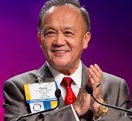

Share your Rotary stories. Tell them to your friends, on social media, and through

Rotary.org. Our Rotary stories are what inspire us, and what encourage others to join us;

they help light up our service, as we work to Light Up Rotary ?

**RI President GARY C.K. HUANG**

## 27 March 2015 The Weekly Bulletin of Rotary Club of Kathmandu Mid-Town bc-37/3.015

******************************************